Detailed Look On Gutter Cleaning Services
Gutter cleaning is an essential part of home maintenance that many homeowners overlook. Regular gutter cleaning helps to prevent damage to the exterior of your property by removing debris, leaves, and dirt that can clog your gutters. Over time, clogged gutters can lead to water overflow, which can cause structural issues, mould growth, and damage to the foundation. As part of routine upkeep, it is highly recommended to invest in gutter cleaning services to ensure your gutters remain in top condition, protecting your property from potential damage. It’s also essential to address any issues promptly to avoid costly repairs down the line. Another key aspect of gutter maintenance is gutter clearance, which goes hand in hand with cleaning. When gutters are not cleared of debris, the excess weight can cause them to sag or pull away from the roof, leading to potential leaks. Routine gutter clearance is especially important during the autumn months when fallen leaves tend to accumulate more quickly. Neglecting this task can result in a blocked system, which may prevent proper water drainage, further increasing the risk of water damage to the roof and walls. Make a search on the below mentioned site, if you are hunting for more information about gutter cleaning services london.

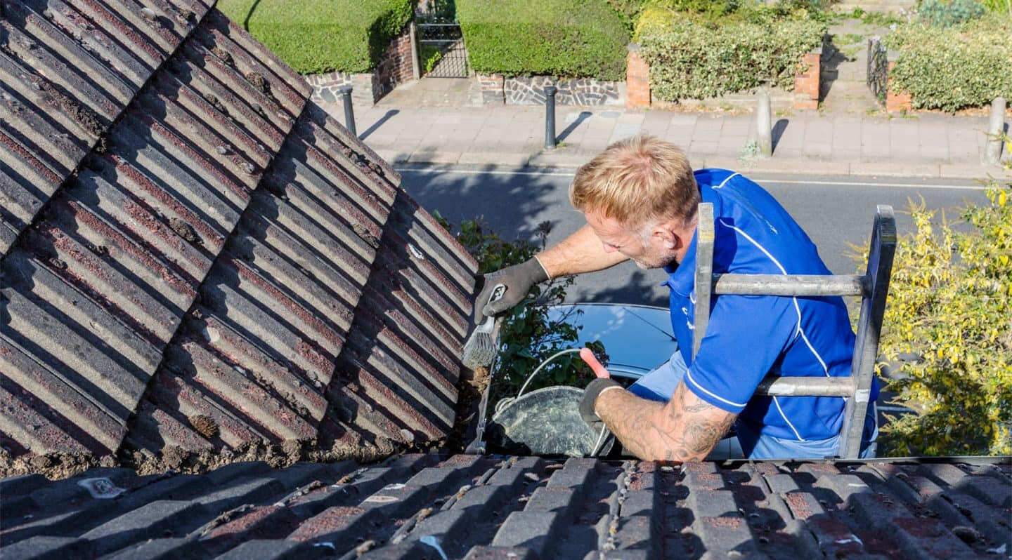

Professional guttering services can ensure your gutters are functioning properly, safeguarding your home. Hiring guttering specialists is crucial for homeowners who want to ensure that their gutter systems are properly maintained and repaired. These experts have the right tools and experience to spot issues early and address them before they escalate. Whether it’s a minor repair or a full gutter replacement, specialists can provide valuable insight into the best course of action. They can also offer advice on how to improve the efficiency of your gutters, ensuring that they remain in excellent condition throughout the year. Regular maintenance from professionals helps avoid expensive repairs in the future. Sometimes, gutter repair is necessary if your gutters are showing signs of wear and tear. Over time, gutters can become cracked, rusted, or loose, making them ineffective at carrying rainwater away from the home. A simple gutter repair can save you from having to replace the entire system. If left unchecked, damaged gutters can cause significant water damage to your home, leading to leaks, mould, and mildew problems. With professional help, you can quickly identify problem areas and restore your gutters to full functionality, keeping your home safe from potential water-related damage.

In cases where your gutters are too damaged or outdated to function properly, gutter replacement may be necessary. This process involves removing the old system and installing a new, more efficient gutter system that will last longer and provide better protection. Choosing a quality gutter replacement service can help you avoid frequent maintenance costs in the future. Replacing old or ineffective gutters can also improve your home’s overall drainage system, preventing water damage to the foundation, landscaping, and roof. This investment pays off in the long term by maintaining the integrity of your home. Ultimately, the key to maintaining a well-functioning home is regular gutter cleaning, proper gutter repair, and timely gutter replacement when necessary. Ensuring your gutters are clear of debris and in good condition helps protect your property from water-related damage and costly repairs. Working with professional guttering services and guttering specialists ensures that your gutter system stays in optimal condition, reducing the risk of issues like leaks, sagging, and foundation damage. Whether you need cleaning, clearance, or repairs, investing in regular maintenance is one of the best ways to safeguard your home.

