Information On Ear Stretching Guide
Ear stretching has become a popular way for individuals to express their unique style and embrace a bold look. For those just starting, understanding the process is key to achieving safe and successful results. Selecting the right body jewellery is the first step, as high-quality materials are essential for preventing irritation or infection. Beginners often wonder how to stretch ears safely without causing damage, which requires patience and the right tools. Following an ear stretching guide can help you navigate each stage of the journey, ensuring your experience is both smooth and enjoyable. Always choose reliable resources and advice for optimal results. When starting your ear stretching journey, visit a trusted body piercing jewellery shop to source professional-grade tools and accessories. These shops often provide detailed information on the process, including how to stretch your lobes without injury. Stretching requires gradual progress, with each size increment carefully planned to avoid damaging the tissue. Keeping a clean environment and practising good hygiene throughout the process is essential to reduce risks. Make a search on the following website, if you're searching for more details concerning ear stretching guide.

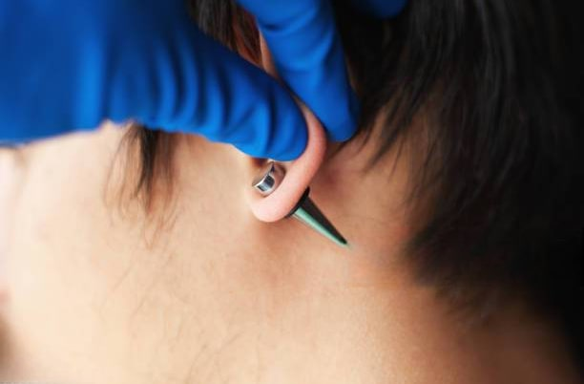

Investing in durable body jewellery and piercing supplies ensures comfort and longevity, enabling you to maintain the health of your stretched ears for years to come. Understanding ear stretching sizes is crucial for managing the transition between different jewellery dimensions. A detailed ear stretching size guide or ear stretching size chart can help you determine the appropriate intervals for progressing through sizes. Typically, waiting six to eight weeks between stretches allows the tissue to heal and adjust naturally. Skipping sizes or rushing the process can lead to complications, such as tearing or infection. By sticking to a methodical approach and adhering to recommended timelines, you can achieve beautifully stretched earlobes that reflect your personal style while avoiding unnecessary setbacks. For those wondering how to stretch your ears, it’s important to start small and use a taper or stretching kit designed specifically for this purpose. The process should never be rushed, as patience is key to achieving healthy, permanent results. After each stretch, proper aftercare, including cleaning and moisturising the area, supports the healing process. Experimenting with different materials and designs in your body piercing jewellery collection allows you to personalise your look as your lobes grow.

If any discomfort or redness occurs, it’s a sign to pause and let your lobes recover before proceeding further. The versatility of stretched ears allows for endless creativity in choosing body jewellery styles. From classic tunnels to vibrant plugs, there’s something for every taste. Reliable body piercing jewellery shops offer an extensive range of options, making it easy to switch up your look. Embracing a thoughtful approach to stretching ensures your ears remain healthy while giving you the freedom to explore new styles. As your journey progresses, you’ll develop a deeper understanding of how to stretch lobes effectively and safely. With the right guidance and tools, achieving your ideal ear stretching goals becomes a rewarding experience. Through careful planning and dedication, ear stretching becomes an art form that blends self-expression with skill. By following a trusted ear stretching guide and adhering to expert advice, you can ensure a safe and successful journey. Each step brings the opportunity to experiment with beautiful body jewellery, adding a unique flair to your personal aesthetic. Whether you’re just beginning or are well into the process, maintaining patience and care is vital. With the help of reliable ear stretching size guides and a commitment to proper techniques, you’ll achieve stunning stretched earlobes that showcase your individuality.

