The Importance Of Protein Shaker Bottles
The use of protein shakers has become a staple in the fitness world, offering a convenient way to mix protein powder with liquids for quick consumption. With the growing demand for healthier lifestyles, shaker bottles have evolved to meet various needs. From basic designs to advanced features, these bottles provide a versatile solution for mixing drinks on the go. Whether you're preparing a protein shake, smoothie, or other beverages, the right shaker bottle can significantly improve your experience. The combination of functionality and design makes these bottles a must-have for anyone who wants to stay hydrated and nourish their body after a workout. Protein shaker bottles come in many shapes and sizes, but the key to their versatility lies in their design. Many shaker bottles are equipped with built-in mixers or wire whisks that ensure smooth and consistent blending of ingredients. This makes it easy to mix protein powder with water or milk, creating a smooth and lump-free shake. Some premium shaker bottles also offer additional compartments for storing powder, supplements, or even snacks. If you are looking for more information on premium shaker bottle, look into the mentioned above website.

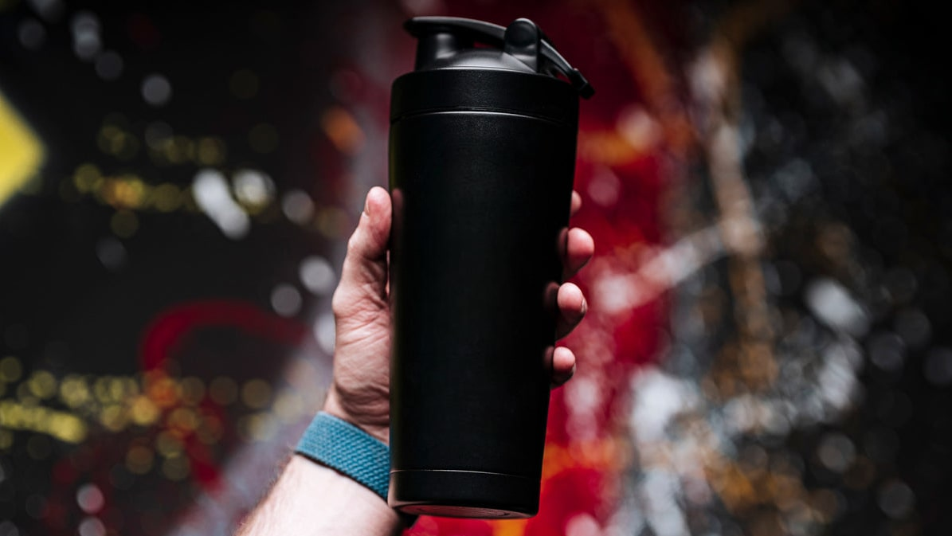

The ability to store multiple items in one bottle adds extra convenience for those on the go, reducing the need for carrying multiple containers during a workout session or while travelling. The choice of materials in protein shaker bottles plays a significant role in their functionality and durability. Many bottles are made from high-quality, BPA-free plastics, ensuring that they are safe to use and easy to clean. However, stainless steel protein shakers are gaining popularity due to their durability and ability to maintain the temperature of drinks. A brushed steel protein shaker is especially effective at keeping your drinks cool for extended periods, making it a great option for hot summer days or long gym sessions. The premium material also gives the shaker a sleek and stylish look, making it a desirable choice for those who appreciate both form and function. The versatility of protein drink shaker bottles extends beyond just protein shakes. These bottles can easily be used for preparing smoothies, meal replacement drinks, or even mixing pre-workout supplements. With the growing trend of health-conscious individuals seeking more variety in their nutritional intake, shaker bottles have adapted to accommodate various needs. For instance, protein shake shaker designs that feature larger capacities are perfect for mixing larger portions of smoothies or meal shakes.

This flexibility makes the shaker bottle an essential item not only for fitness enthusiasts but also for those who want to stay healthy throughout the day. As the market for protein powder shaker bottles continues to expand, manufacturers are introducing even more innovative designs to cater to specific needs. Some bottles now come with features such as leak-proof lids, easy-to-open caps, and ergonomic handles for improved portability. Additionally, there are shaker bottles that come with built-in storage for protein powder, ensuring that you always have what you need for a quick shake. The evolution of the protein shaker bottle has made it a convenient, practical, and indispensable tool for anyone looking to improve their health and fitness regimen, whether at home, the gym, or on the go. In conclusion, the design and functionality of protein shakers have come a long way. With advancements in materials, ease of use, and added features, these bottles have become more than just a tool for mixing protein powder. They offer versatility, convenience, and style, making them an essential item for fitness enthusiasts and anyone committed to a healthy lifestyle. Whether you prefer a traditional protein shaker bottle or opt for a stainless steel protein shaker, the variety of options ensures there is a shaker bottle for every need.

